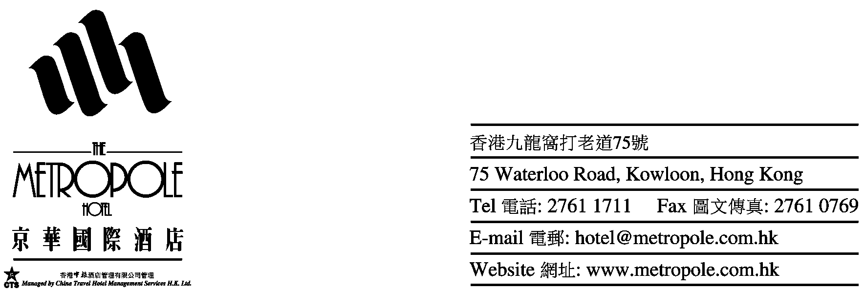

To: Emily Law ( Assistant Sales Manager) – The Metropole Hotel
Address: 75 Waterloo Road, Kowloon , Hong Kong
Tel : 852 27611 1711 Fax : 852 27603 3603 Direct E-mail : cs@metropole.com.hk

ACCOMMODATION RESERVATION FORM

THE 2ND INTERNATIONAL CONFERENCE ON SCIENTIFIC COMPUTING & PARTIAL DIFFERENTIAL EQUATIONS & THE 1ST EAST ASIA SIAM SYMPOSIUM

Name : #Prof/Dr/Mr/Ms/Mrs (First name) (Last name)

#Prof/Dr/Mr/Ms/Mrs (First name) (Last name)

Contact No. : (Tel) (Fax) (Email)

Room Rate : No. of Room Superior Room at HK$500* per room per night (room only)

No. of Room Executive Room at HK$570* per room per night
(Includes daily buffet breakfast for 1 person in Executive Lounge)

No. of Room Executive Room at HK$650* per room per night
(Includes daily buffet breakfast for 2 persons in Executive Lounge)

Special Request : Queen Size Bed Twin Bed Non-smoking Smoking

Arrival Date : Flight Time

Departure Date : Flight Time

*Free access to the internet via in-room broadband line (unlimited usage)
Airport Shuttle : Arrival Departure
One –way airport transport by shuttle bus on complimentary basis for guests to stay one night. Round –trip airport transport
on complimentary basis for guests to stay two consecutive nights or more.

Booking Guaranteed By : Amex Visa Master Diners Deposit by Bank Draft

Name of card holder : Card No. : Expiry Date :

* The rate is subject to 10% service charge and 3% government tax.
- Airport Shuttle Service is provided based on a fixed time schedule. (Please approach B8 counter in HK airport)

Date of Application : Signature :

Notes : 1. The special rate is only available to register delegates of the above conference.
2. All bookings should be guaranteed by a credit card
3. The deadline for making reservation is 8 Dec 2005 after which accommodation is subject to availability.
4. Room rate of one night accommodation will be charged if cancellation cannot be notified by writing to the hotel 48 hours prior to due arrival date.

HOTEL USE ONLY

CONFIRMED WAITING LIST NOT CONFIRMED By Date

