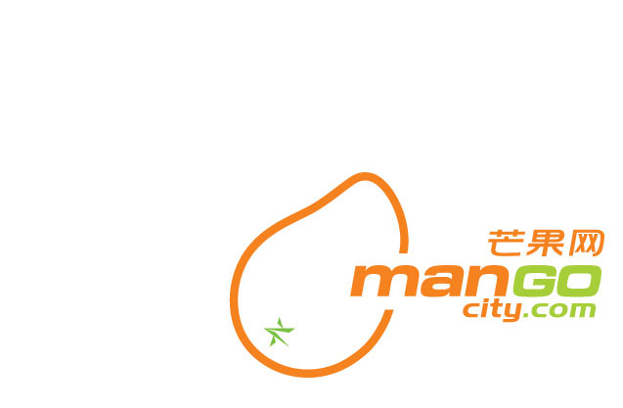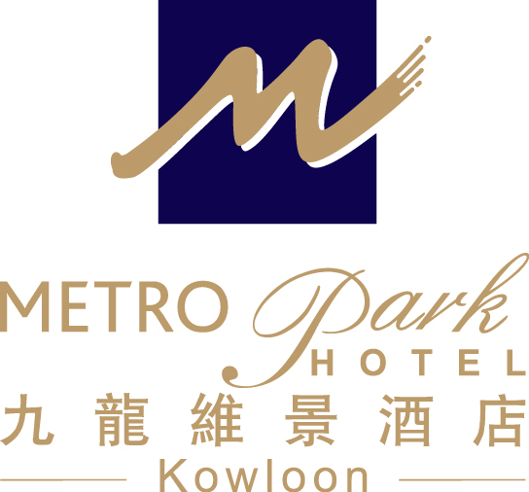
Hong Kong Baptist University
(The Third International Conference on Scientific Computing and Partial Difference Equations)
– Accommodation Reservation Form (07 – 13 December 2008)

To: Anita Hung (Asst. Business Development Manager)

Metropark Hotel Kowloon
Address : 75 Waterloo Road, Kowloon , Hong Kong
Tel : 852 2761 1711 Fax : 852 2760 3603
Direct E-mail: abdm.hkkl@metroparkhotels.com

Name: Mr/Ms/Mrs (First name) (Last name)

Contact No. : (Tel) (Fax) (Email)

Date: 07 – 13 December 2008

Room Rate: No. of Room Comfort Single/Double Room at HK$650 nett per room per night

Daily buffet breakfast: Yes No

Special Request: Non-smoking Smoking

Airport Shuttle: Arrival Departure

- Airport transfer by shuttle bus at HK$95.00 per person per way
- Daily buffet breakfast at HK$60.00 net per person on consumption basis
- Free in – room broadband Internet access (unlimited usage)
- Welcome fruit set-up and free local telephone calls
- Free use of Hotel’s swimming pool & fitness room facilities (Open from March to December)

Booking Guaranteed By: Amex Visa Master Diners

Name of card holder: Card No. : Expiry Date:

* The rate is inclusive of 10% service charge and 3% government tax.
- Airport Shuttle Service is provided based on a fixed time schedule. (Please approach B05A counter in HK airport)

Date of Application: Signature:

Notes: 1. The special rate is only applicable to delegates of the above conference.
2. All bookings should be guaranteed by a credit card
3. The deadline for making reservation is on or before 3 November 2008 and the accommodation is subject to availability.
4. Room rate of one night accommodation will be charged if cancellation is notified by writing to the hotel 72 hours prior to due arrival date.

HOTEL USE ONLY

CONFIRMED WAITING LIST NOT CONFIRMED By Date

